The following pages are examples only, please read the Blue Book Planning chapter and create your own planners/rosters
Yearly
 |  |  |  |  | BBB
 |  |  |  |  | AFL GF
 |  |  |  |  |  |  |  | Christmas |  |  | Easter
 |  |  | AS Show
Sport’s Carnival season
Cooler time for bush trips |  |  |  |  |  | Hot time
 |  |  | Akatjiri season |  |  | Pura Season
 |  |  |  |  |  | Possible rainy season
 |  |  |  |  |  | Pool Season
 |  |  |  |  |  |  | Culture time
Holidays |  | Holidays | Holidays |  | Holidays | Holidays |  | Holidays | Holidays
April | May | June | July | Aug | Sept | Oct | Nov | Dec | Jan | Feb | March

Template Yearly Planner
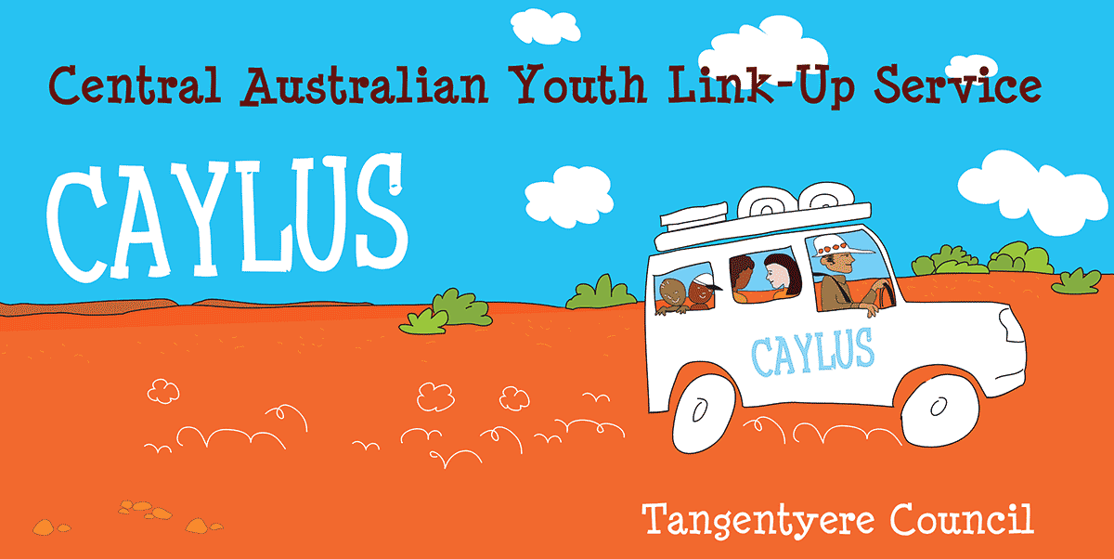

Activity | Week 1 | Week 2 | Week 3 | Week 4 | Week 5 | Month Total
Country/Bush trip
Language
Media consuming
Media creation
Food/bush tucker/hunting
Family focus
Art
Etc.
Etc.
Weekly total
Template Cultural Activity Tracker

 | Tuesday | Wednesday | Thursday | Friday | Saturday
Morning |  |  | 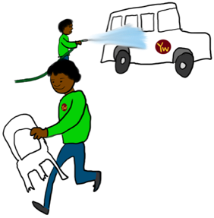
Afternoon | 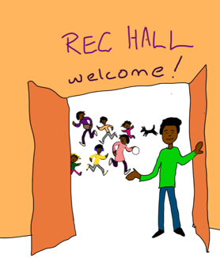 |  |  | 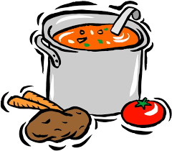 | 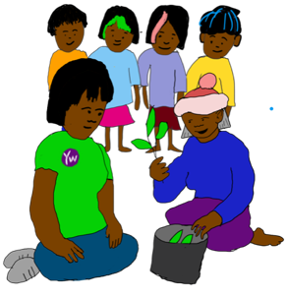
Night | 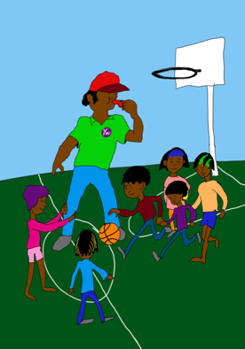 | 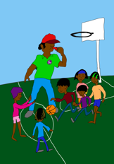 | 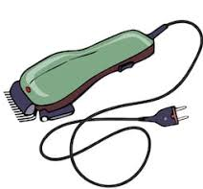 | 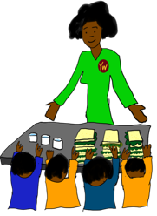
Organisation LOGO

 | Tuesday | Wednesday | Thursday | Friday | Saturday
Afternoon | 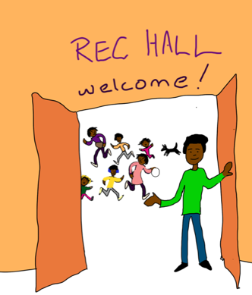
Night |  | 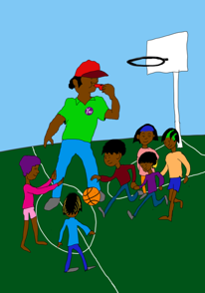
Organisation LOGO

